
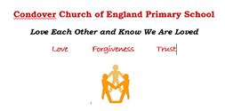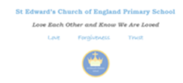

French Endpoints 2023 - 24
End of Key Stage 2
- Listen attentively to spoken language and show understanding by joining in and responding
- Explore the patterns and sounds of language through songs and rhymes and link the spelling, sound and meaning of words
- Engage in conversations; ask and answer questions; express opinions and respond to those of others; seek clarification and help
- Speak in sentences, using familiar vocabulary, phrases and basic language structures
- Develop accurate pronunciation and intonation so that others understand when they are reading aloudor using familiar words and phrases
- Present ideas and information orally to a range of audiences
- Read carefully and show understanding of words, phrases and simple writing
- Appreciate stories, songs, poems and rhymes in the language
- Broaden their vocabulary and develop their ability to understand new words that are introduced into familiar written material, including through using a dictionary
- Write phrases from memory, and adapt these to create new sentences, to express ideas clearly
- Describe people, places, things and actions orally and in writing
- Understand basic, French grammar including feminine and masculine forms and the conjugation of high frequency verbs; key features and patterns of the language; how to apply these
Children will leave St Edward’s as linguists who:
- Have the confidence to speak with intonation and pronunciation
- Are developing a strong awareness of and interest in differing cultures
- Are resilient learners with a passion for languages
- Can use language with spontaneity
- Are inquisitive

