
Weekly Newsletter
Week Ending Friday 12th June 2026

Makaton Sign of the Week

Sign | Meaning
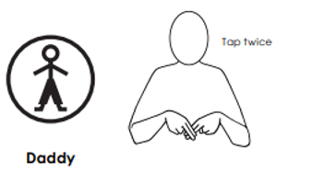

Attendance
Please see the attendance percentage data for the school and each class this week.

Whole School | Dragonflies | Osprey
94.0 % | 88.2% | 98.3%

Celebrating our Achievements!
Awards will continue next week!

Class Overviews

Summer Term overviews are now available on the school website.
School website - Learning - Class Pages

Dragonfly

Osprey | This week Osprey Class have been learning about how the Vikings traded goods and the various trade routes they used across the world. In Science, we explored the relationship between animal size and heart rate. We created scatter graphs in order to help us interpret any patterns in the data. We finished the week by learning and performing some Samba rhythms in class.

Pictures from Dragonflies and Ospreys:

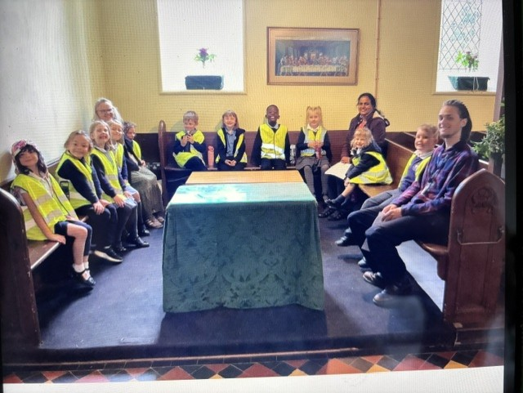

Key Dates

SCHOOL DATES
Summer Term – HT1 – 6 weeks
25th June | Y6 Leavers’ Service – Hereford Cathedral | Y5 + 6
29th June | Year 5 and 6 Residential Trip | Y5 + 6
TBC | Y6 Treat Day | Y6
TBC | Reports to parents | Whole school
7th July | Parent drop-in | Whole school
9th July | Transition morning | Whole school
TBC | Summer performance | KS2
TBC | Leavers’ Church Service | Whole school
16th July | End of Summer Term | Whole
Summer

Parent Notices

A message from Miss Elvins and Mrs Clay

What a wonderful week we have had.
On Monday the whole school took part in our Jewish virtual lesson, where the class learned about traditions and celebrations in an engaging, interactive way. They asked thoughtful questions and represented the school beautifully.
We’ve had a lovely end to the week with the return of the sunshine, meaning that children have been able to enjoy their time outdoors. The children have worked brilliantly across all areas of learning.
Next week we look forward to the return of more sunshine, and lots more exciting activities for our children.
Wishing you all a restful and wonderful weekend.

Wishing you all a restful and wonderful weekend.

KS2 Swimming

A reminder that swimming lessons continue on a Tuesday for Years 5 and 6 and will run all the way until 14th July. Please make sure to send your child into school with a towel, swim shorts/costume and goggles. Thank you.

Shrewsbury Town

Shrewsbury Town are at St Edwards each Wednesday for After School sport club. This term, the focus will be rounders for KS2 and target games for KS1. It’s a great opportunity to get the children outdoors and playing together as a team. If you would like to sign your child up, please email or call the office. The club runs from 3.15 to 4.15pm.

Polite reminders

Parking:
We politely ask all parents who need to drive to school, to remember to park legally, considerately and safely at school drop off and pick up times. This will ease congestion around the school and help make the area around our school a safer place for our children. Alternatively, when possible, please walk to school or park further away this will help to keep our school street a safer place as well as having health benefits. We all want our children to be safe and by respecting the space outside school we can do this together.

Toys:
We’ve noticed a few toys being brought into school recently. Please could we ask children to leave these toys at home. They can be a distraction in class and we also don’t want anything to get damaged.
Suncream:
As we’re heading into the season of warmer weather, we encourage children to apply sunscreen before school. Water bottles are essential and sun hats are encouraged.

Snacks:
We encourage children to bring snacks to school and know the importance of keeping their energy levels up throughout the day, however, we have noticed some unsuitable snacks being brought in such as Tictacs and boiled sweets. Please ensure your children do not bring snacks of this kind into school. Thank you for your co-operation.

Fruit: If you are sending grapes in your child’s lunchbox, please can you make sure that they are cut up – thank you.

Reading
.
Reading is one of the most powerful habits a child can develop. Just a few minutes of shared reading each day strengthens vocabulary, builds confidence, and opens the door to new ideas and worlds. Whether it’s a bedtime story, a chapter before dinner, or a quiet moment at the weekend, these small routines make a lasting difference.
We encourage you to spend time reading with your child or talking about the books they enjoy. Your involvement helps them see reading not as a task, but as something to look forward to. Next week the children will be coming home with new reading diaries, where you can record these shared moments. More information will follow.
Thank you for supporting a love of books at home. It truly matters.

Reading Supports Writing
Strong readers often become confident writers.
At home: Encourage drawing or writing inspired by a story.
Recommended read: Fantastic Mr Fox by Roald Dahl — classic storytelling.

Flourishing Moments

We know that many of our children partake in lots of exciting activities outside of school. We love to hear about them, and all the amazing things that our children achieve outside of our school hours. Please do send in your flourishing moments so that we can share in these proud moments too.
Please email a photo, with a description of the achievement to admin@stedwards.dhmat.org.uk.

Shredded Paper
As part of our Eco commitment, school would like to offer shredded paper out to families who may like this for their pets, chickens, guinea pigs etc. If this would help you, please speak to Jenny in the school office.
Thank you

Book Swap
At St Edward’s, there will be a Book Swap available every day in the foyer of the school. You are welcome to bring a book and swap it for a book from the box. It’s free for everyone to use, including parents. There will be a box for children’s books and a box for adult books.

PE + Forest School

 | PE | Forest School
Dragonfly Class | Wednesday | Thursday
Osprey Class | Tuesday & Wednesday

Uniform Policy
A polite reminder of our Uniform Requirements.
Our school uniform includes:
- Grey skirt, pinafore dress, trousers or shorts
- White polo shirt
- Navy blue sweater or cardigan with school emblem
- White or grey socks/tights
- Blue gingham dress (summer-time only)
- Flat, comfortable black shoes (no trainers, pumps or sandals).

PE Kit:
- Black shorts
- Light blue polo shirt with school emblem or a plain light blue polo shirt
- Navy blue or black jogging bottoms
- Navy blue or black sweatshirt or hooded jumper
- White socks
- Trainers (suitable for outdoor use in all weathers)

All clothing should be clearly labelled with your child’s name.

School sweatshirts, cardigans, PE t-shirts can be purchased from Decostitch, which is our preferred uniform provider.
Items can be purchased online by visiting www.decostitch.co.uk.
Telephone: 01743 462265

Tin Tuesday
Every Tuesday, you are invited to bring a tin or a box of food so we can donate it to the food bank. There will be a box by the gate for you to place your donations in. Any item, any size is welcome and there is no expectation for you to buy items specifically.

Policies
We have been reviewing and updating several of our school policies to ensure they remain current, effective, and fully aligned with statutory guidance. This is part of our regular cycle of school improvement and helps us maintain the highest standards for our pupils. These are now available on our school website.

Breakfast & After School Clubs
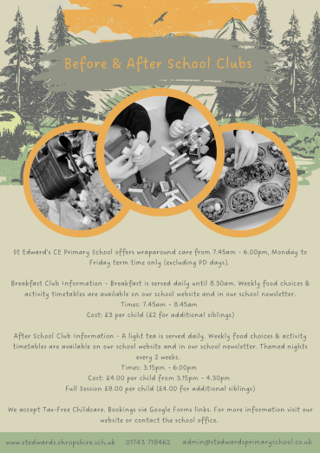

Breakfast Club
Our Breakfast Club runs every morning during term time (excluding PD days) from 7.45am at a cost of £3 per child (£2 for siblings if more than one child from a family is attending).
Breakfast served daily. A range of activities is provided, including yoga, crafts, games, children’s TV, reading, Lego building and much more.
After School Club
Our After School Club Provision runs every day from 3.15 until 6pm during term time and excluding PD days.
The cost is £8.00 for the full session (£4 for siblings if more than one child attends) or £4.00 from 3.15pm – 4.30pm.
A light tea is served each day which the children often enjoy helping to prepare.

We accept tax free childcare. Please email the office for more information: admin@stedwardsprimaryschool.co.uk

Weekly food choices and activity timetables will be shared on the school website and in the newsletter. Example activities include: pizza making, hedgehog handprints, Lego portraits, gardening.

BOOKINGS
Please use the booking system on SchoolMoney.

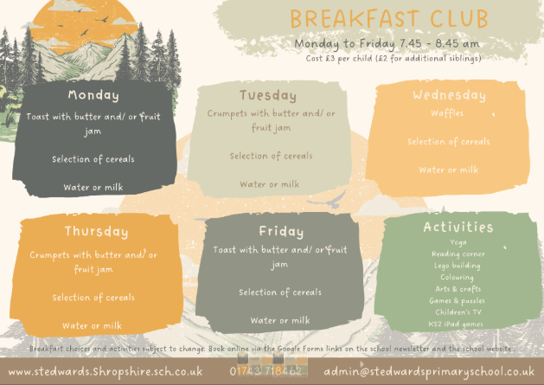

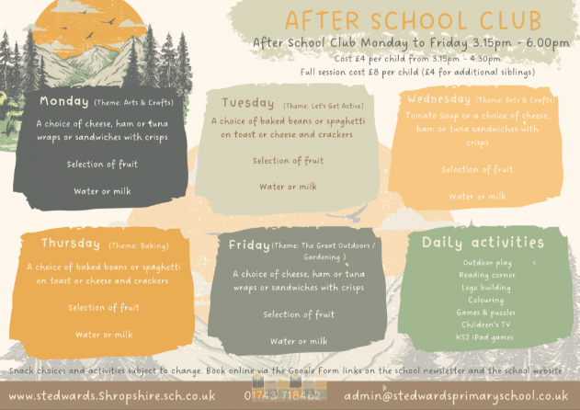

Free School Meals
All Reception, Year 1 and Year 2 children are entitled to Universal Infant Free School Meals (UIFSM). If your child is in KS2 they will no longer be entitled to this and payment for school meals will need to be paid via SchoolMoney.
If you think your child should be entitled to free school meals, please visit: https://www.gov.uk/apply-free-school-meals to check eligibility and apply.
Even if your child is entitled to UIFSM’s and you fit the eligibility criteria we would encourage you to apply as the school receive funding for this. If your child is entitled to free school meals, they will also qualify for the Holiday Activity and Food (HAF) Programme. More information about this can be found here: https://educationhub.blog.gov.uk/2022/04/06/what-you-need-toknow-about-the-holiday-activities-and-food-haf-programme-2/
Thank you for your continued support as we work to keep our school community safe, consistent, and well-informed.

Local Events





Contact
Please send all emails to admin@stedwards.dhmat.org.uk
Telephone: 01743 781462

Wishing you all a wonderful weekend
The St Edward’s Staff Team
St Edward’s CE Primary School is proud to be part of
Diocese of Hereford Multi Academy Trust (DHMAT)




